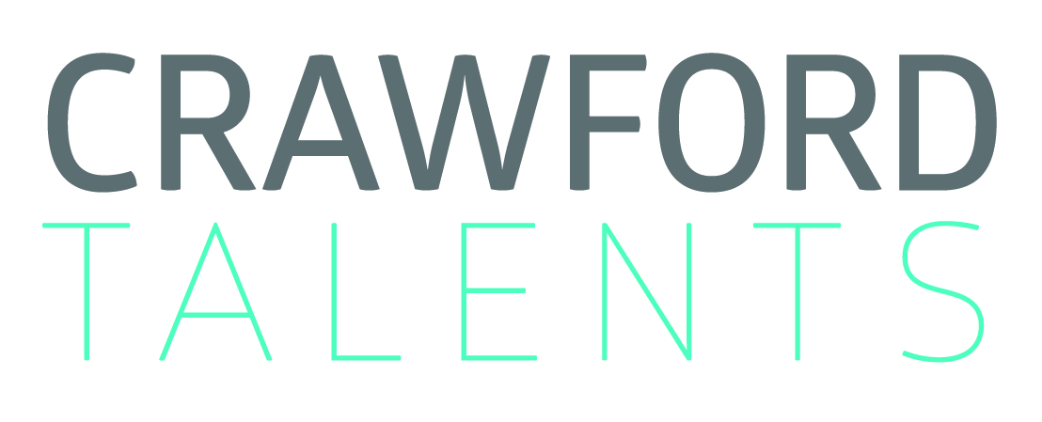

Caprice Crawford | Founder
Crawford Talents International Actors Management Agency
Uhlandstrasse 53 | Berlin 10719 | M +49 172 30 88868

KELVIN MAXWELL
NGOMA
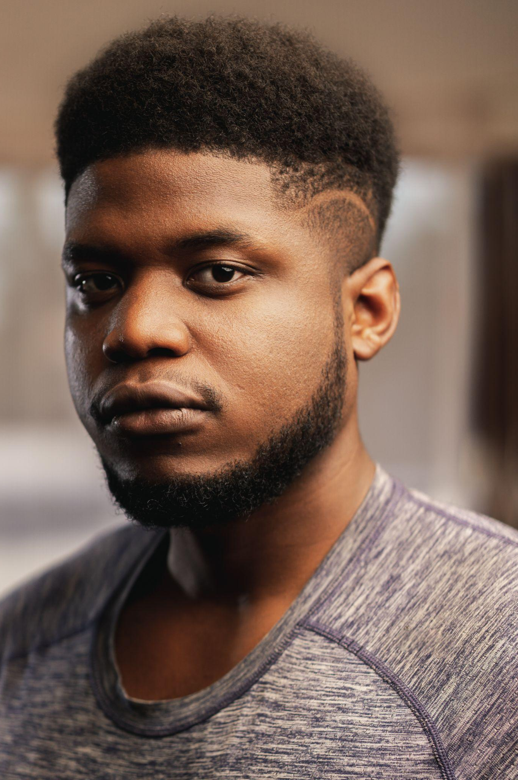
Nationality​ : Malawian
Height:​ 6'2”' (180cm)
Age:​ 25
Appearance:​ African
Eye Colour​ : Black
Hair Colour​: Black
Hair Length​: Medium
Voice​: Base​
Location:​ Malawi | Southern Africa
Others: |Aerobics | Martial (basic)
Sport : Basketball
Gym, Aerobics, running.

movie | tv | theatre
movie selection
2019 The Boy Who Harnessed the Wind
Feature Film | NETFLIX| directed by Chiwetel Ejiofor| Charity Malamusi - SR
2021 Fatsani - Tale of a Survivor
Feature film | HD plus Creations|Showmax | directed by Gift Sukez Sukali| Lipenga - Lead
2021 Sabbali - Waters on the Sand
Feature Film |Mwape | directed by Maxwell Mwape| Muzara- Lead
2021 Highbrow
Feature Film | directed Chazz Daddie | Simba - SR
2022 True spies
Podcast | Investigative Journalism - Voice over Narration
2018 Nyasaland
Feature Film | Rising choreos Films | directed by Joyce Chavula | Limbani - Lead
2018 Spouses and Workmates
Series | Neptune prod | directed by Flora Suya| Patrick - SR
2020 Moringa
Commercial | Yamba | directed by Teddy Cherim| Moffat - Lead
2020 Elantine
Commercial | G & G | Lead

theatre selection
2019 De summer blow
Theatre | directed by Misheck Mzumala| Lead

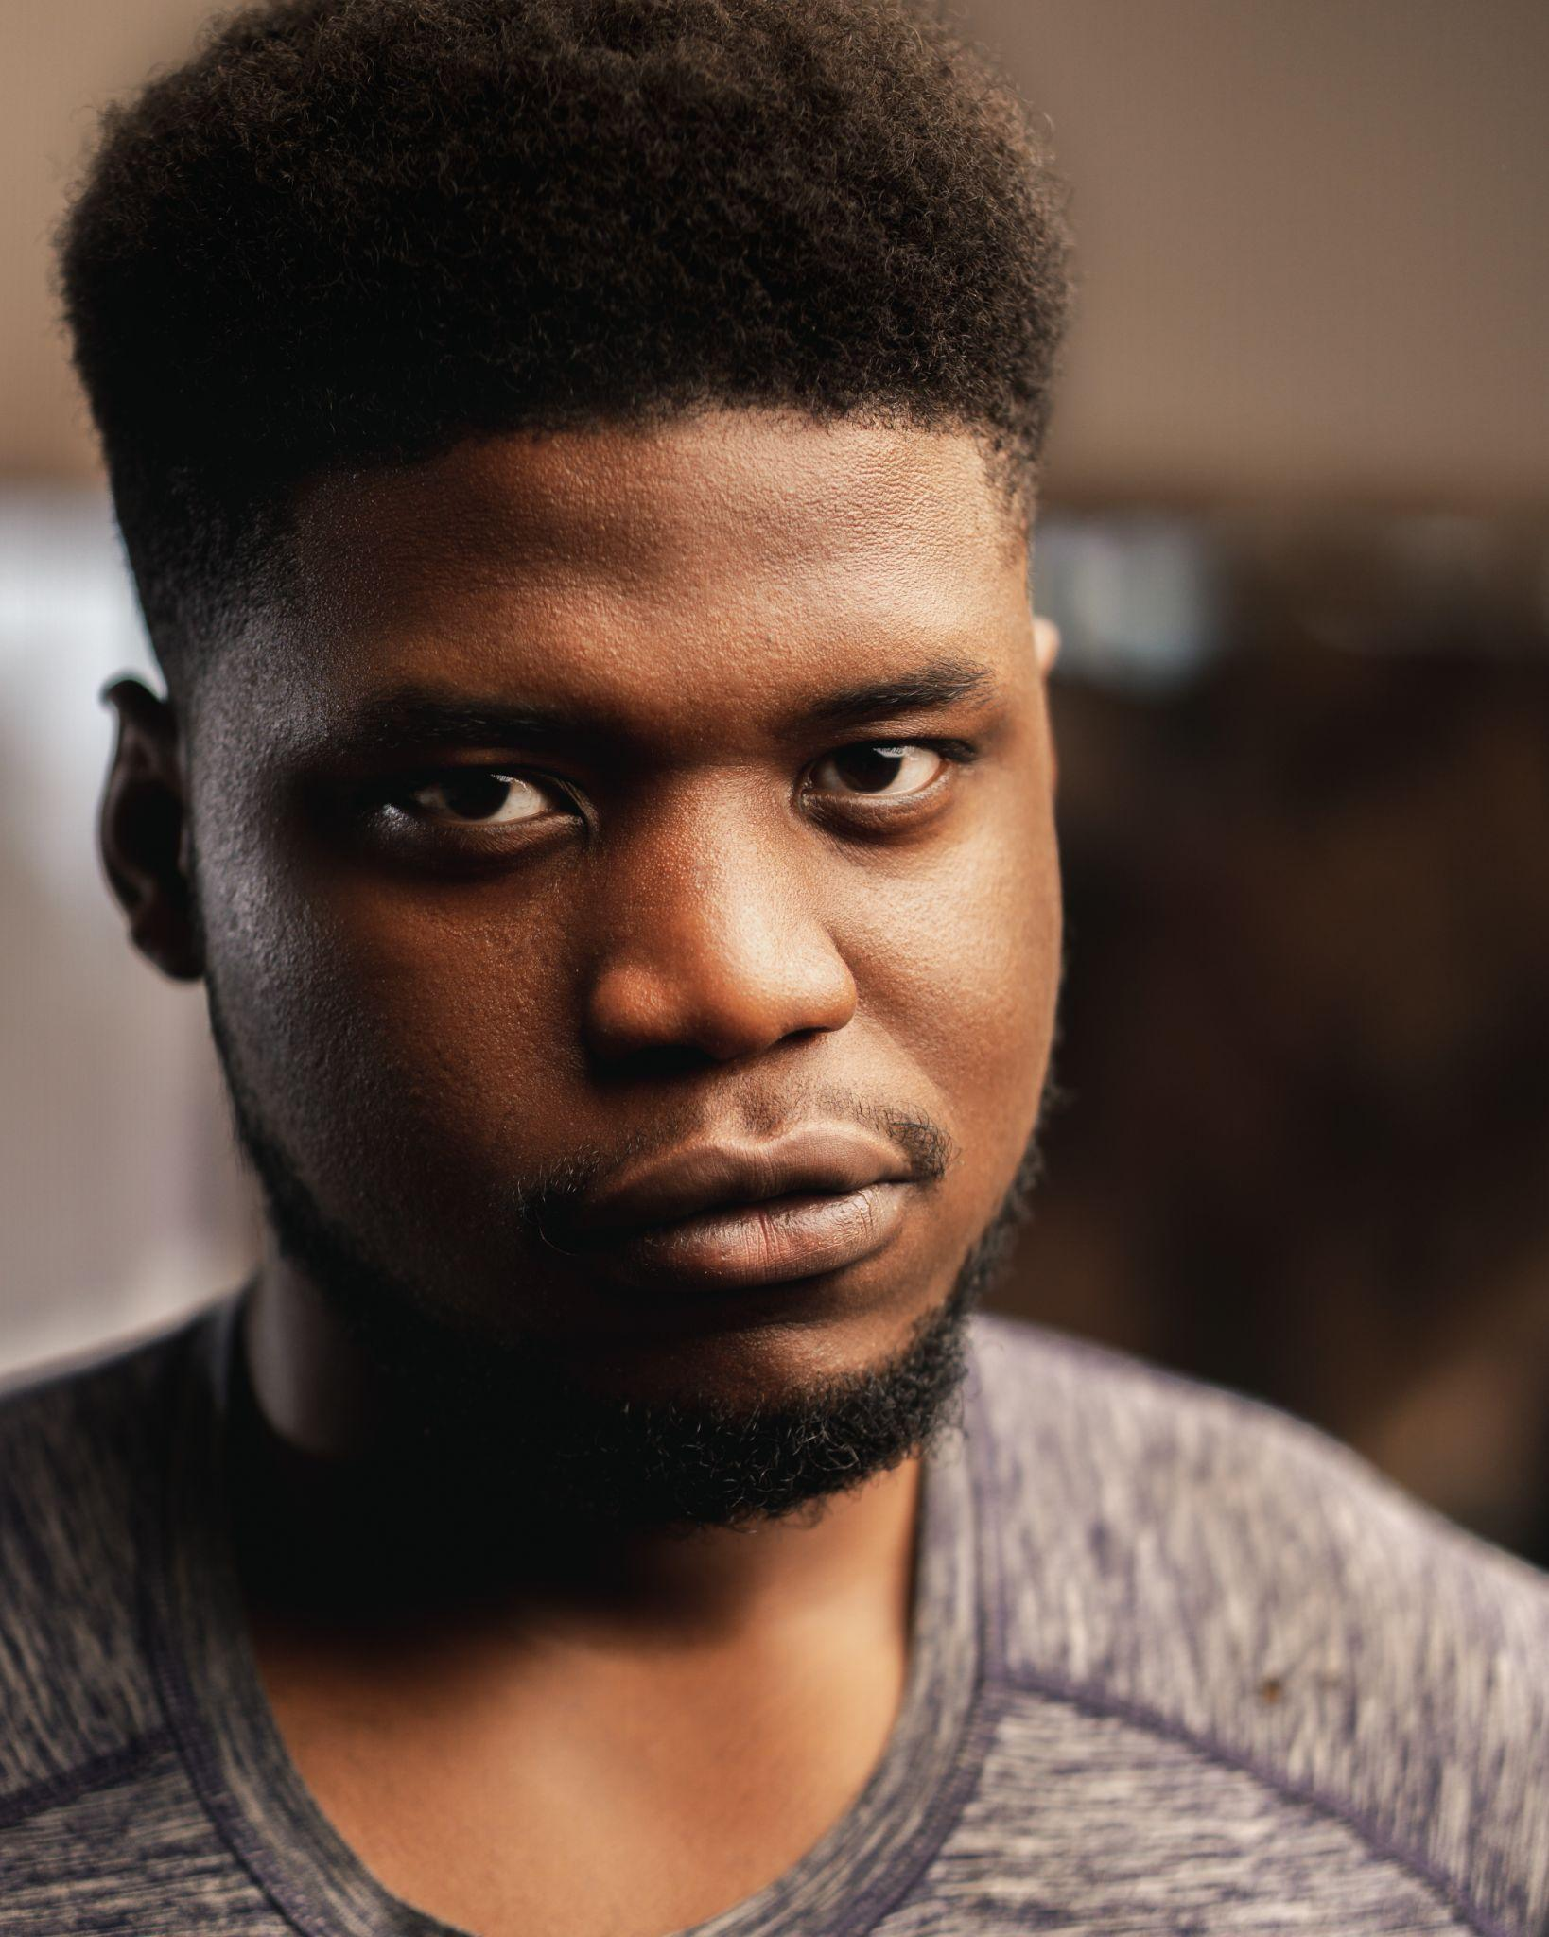

KELVIN MAXWELL NGOMA

